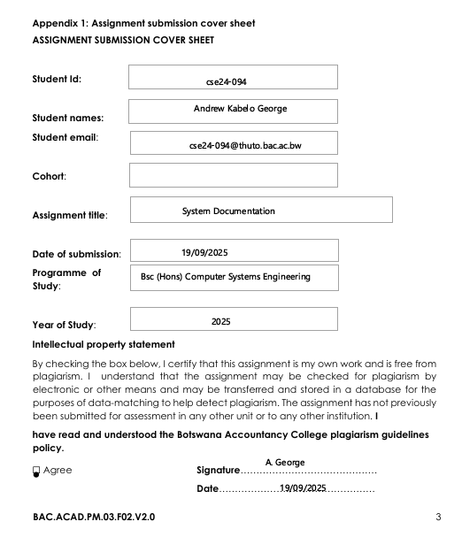

**Functional Requirements**

**1. Management of Customers**   
  
 **a.** **New Customer Registration**   
  
A bank teller will be able to register a new individual customer using the system by entering their first and last names as well as their physical address.   
  
By recording the firm name and address, the technology will enable a bank teller to register a new corporate customer.   
  
Every new customer will be given a unique customer ID by the system when they register.

**2. Management of Accounts**   
  
**a. Open Account**  
  
- A bank teller will be able to open a new savings account for an existing customer using the system.   
  
- A bank teller can only start a new investment account for an existing customer through the system if they make an exact BWP 500.00 first deposit.   
  
- Only after the employer's name and address are entered will the system permit a bank teller to open a new check account for an existing client.   
  
- Every new account will be given a unique account number by the system.   
  
**b. Access Account Information**   
  
- A bank teller will be able to see every account that a certain customer

- Each account's type, number, and current balance will be shown by the system.

**3. Processing Transactions**  
**a. Money Deposited**   
  
-A bank teller will be able to deposit any positive quantity of money into any existing account (savings, investment, or check) thanks to the system.   
  
- The account balance will be instantly updated by the system to reflect the new balance.

**b**. **Withdraw Money**  
  
- If the withdrawal amount is positive and stays within the allowed balance, the system will permit a bank teller to take money out of an investment or check account.   
  
- Any withdrawals from a savings account will be disallowed by the banking system.   
  
- After a successful withdrawal, the system will instantly update the account balance.

**c. Apply Interest Every Month**- The system will have a feature that allows a bank teller to initiate the monthly interest application.   
  
**-** The system will compute and credit interest to all savings accounts at a rate of 0.05% of the current balance when it is triggered - The system will compute and credit interest to all Investment Accounts at a rate of 5% of the current balance when it is triggered  
- Cheque accounts will not be subject to interest charges from the system **4. System Function   
  
a. Persistence of Data**- All data, including account information, transaction records, and client information, will be permanently stored in a database by the system.- When the application is restarted, no data will be lost.

**Non-Functional Requirements**

**1. Practicality**   
  
**a. Capability to Learn**   
  
- After one (1) hour of training, the user interface should be sufficiently intuitive for a trained bank teller to complete all essential tasks (opening an account, depositing money, withdrawing funds, and registering customers) without consulting a manual.   
  
**b. Effectiveness**   
  
- From the primary menu, the system will enable a bank teller to conduct a deposit or withdrawal transaction in less than three steps.

1. **Performance & Dependability**   
     
   **a. Accessibility**   
     
   - The system must be built to function without unplanned outages during regular business hours, which are 8:00 AM to 5:00 PM.   
     
   **b. Integrity of Transactions**   
     
   - All financial transactions, including deposits, withdrawals, and interest applications, must be handled fully and precisely by the system. To keep account balances accurate, failed or partially completed transactions must be turned back.

**c. Reaction Duration**   
  
- Under typical operating circumstances, the system must react to any user action such as a button click or menu selection in less than two seconds.

**3. Safety**   
  
 **Security of Data**   
  
- The system will make sure that account balances and customer information can only be changed via the specified system functionalities and not by an unauthorized user directly in the database.

**2. Structural UML Modelling**

1. **USE CASE DIAGRAM**

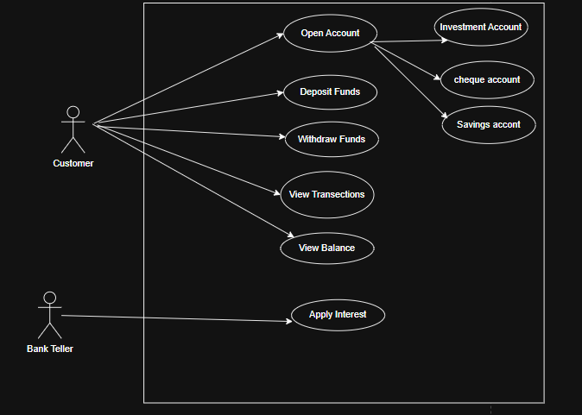 **b. CLASS DIAGRAM**

**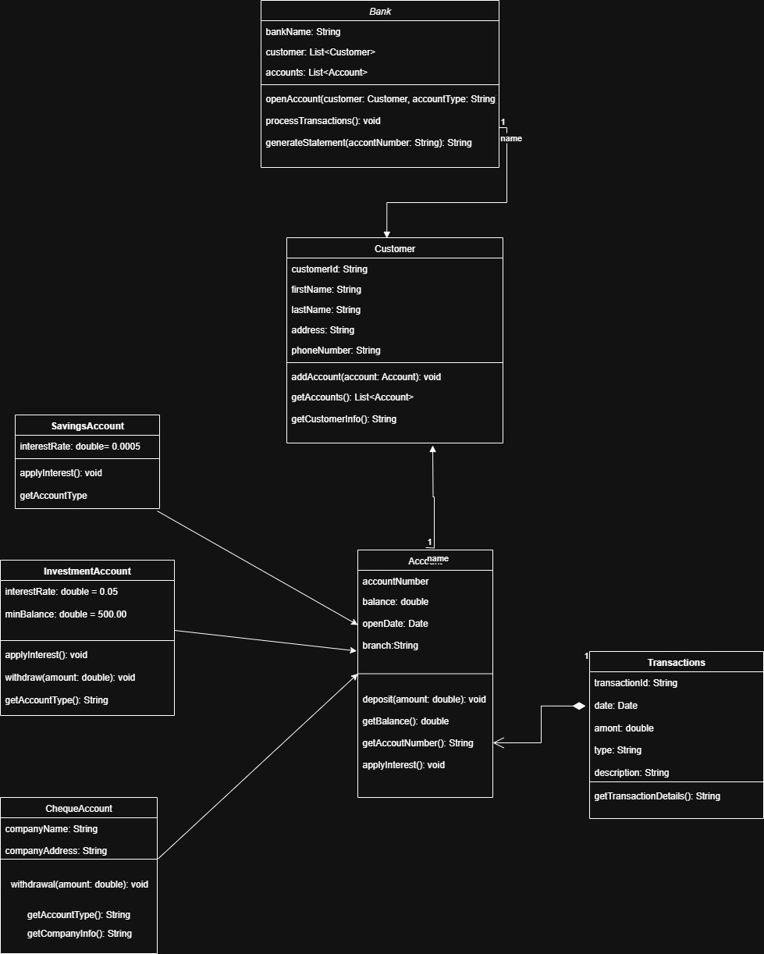  
  
  
c. Sequence**

1. **Deposit sequence**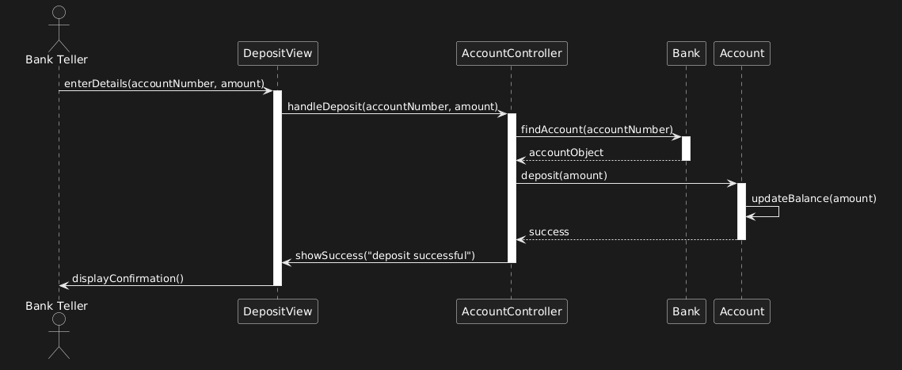
2. **Login sequence diagram  
     
   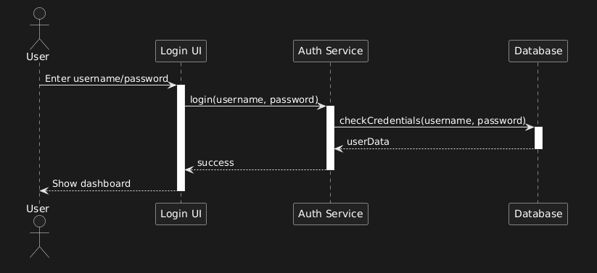**

**Meeting Appendix (Interviewed Themba Moeng)**Features that are essential include several accounts, allowing users to have savings, investment, and check accounts all at once. **Transaction History**: Keep track of every transaction, including the amount, account, date, and kind.   
 **No overdrafts:** You can't take out more money than your account balance**.   
  
Rules for Investment Accounts:** A minimum balance of BWP 500 must be maintained **Authentication:** Both customers and workers usernames and passwords **Reporting:** Transaction history filtered by date range **One Branch:** No support for multiple branches is required. **Rules of Business:** Savings Account: No withdrawals, 0.05% monthly interest **Investment Account:** permits withdrawals, minimum balance of BWP500, 5% monthly interest   
No interest, requires job information, and permits withdrawals from a check account   
  
Technical specifications include a database for user credentials and transactions.   
  
Expandable architecture for the future   
  
No money transfers between accounts  
  
Inter-account transfers are not necessary.   
  
Operations with many branches   
  
Limits on daily withdrawals and deposits (apart from minimum balance regulations)

**The following should be part of the system:**

- authentication system   
  
-Database for transaction logging   
  
-Functionality for reporting   
  
-Calculating interest correctly   
  
-Business rules specific to each type of account   
  
-Rules for balancing validation